**Juelanshe (决澜社, The Storm Society)**

Juelanshe (The Storm Society) was a short-lived movement in early to mid 1930s in China, which was informed by Post-Impressionism. The group, based in Shanghai, emerged following drastic changes to the education system implemented by the Qing Dynasty. From 1875, an increasing number of students went abroad for their education, primarily to Japan and Europe. After 1911, this had a significant impact on art practice as Euramerican art became associated with progress and modernity. European modernist movements became influential from the mid-1920s supported by rapid expansion of book, newspaper and journal publishing. Shanghai, as a treaty port, offered an environment of comparative freedom for artists and intellectuals. Pang Xunqin (庞薰琹, 1906-1985) and Ni Yide (倪贻德, 1901-1970) founded Storm Society in 1931. Pang studied for four years in Paris and sought to establish a modernist Parisian studio in the French Concession. Influenced by a number of artists, notably Picasso, Matisse and Leger, he explored various styles, shifting from representational to almost abstract geometric, montage-like compositions. Ni graduated from the Shanghai Art School and studied Western art in Tokyo from 1927-8. The style of his oil paintings was more consistent, neo-realistic, post-fauvist style influenced by Cezanne, Derain and Vlaminck. He was a well-known art theorist and critic who actively engaged in public debate.

Storm Society’s manifesto articulated their vision of breaking free of tradition and embracing the essence of Western art to steer the future of China: “…we want to hit the rotten art of contemporary China with a powerful wave”; “We must use new techniques to express the spirit of a new era”. They launched with an independent journal that was eventually incorporated into the journal of a less avant-garde, more financially secure association, Mo She (Muse Society) and published thrice monthly.

Pang associated the movement’s goal of self-expression with the traditional Chinese principle of Qiyun, ‘spirit resonance’, whereby subjective interpretation was prioritized over reality. This did nothing to appease Storm Society’s most vocal critics, the city’s Western-trained academic realists led by Xu Beihong (徐悲鴻, 1895-1953). They advocated that the rational, scientific properties of Western art were associated with progress and were scornful about deviations from this convention.

The group held monthly meetings and a total of four annual exhibitions. Over this time members included Chen Chengbo, Deng Yunti, Qiu Ti, Yang Taiyang, Yang Quiren, Zhang Xuan, Zhou Duo, Zhou Zentai, Zeng Zhiliang, Zhou Bichu, Li Zhongsheng, Liang Baibo, Liang Xihong, Zhang Shuqi and Duan Pingyou. Members practiced a wide diversity of styles notably Fauvism, Cubism and Surrealism. Subjects were generally portraits, still life, landscape and nudes. The first exhibition, delayed by a year due to the Manchurian Incident, opened in October 1932.

Subsequent exhibitions generated debate directed at particular works. In 1933 the only female artist, Qui Ti (who later married Pang), exhibited a Fauvist style painting of a potted plant with red leaves and green flowers drawing criticism from Academic Realists. Pang’s *Son of the Earth*, produced in the following year, referred to the drought outside Shanghai. It showed a family in a Pieta-like composition and was read as being critical of China’s nationalist government.

In the final exhibition in 1935 two of the exhibited works with left-wing overtones were deemed controversial. Pang’s work rendered in a mechanical Surrealist style showed a fragmented image of urban life in which a worker turned screws on a giant press observed by a downcast woman. Zhou Zentai used a realistic style influenced by Japanese proletarian art to depict a worker repairing machinery.

After this exhibition the movement went into demise as a result of the insufficient commercial interest to support its members. Pang moved north to take up a position at Peking Art School. Meanwhile the ideal of self-expression was increasingly regarded as bourgeois, the overtly left-wing woodcut movement being more suited to the changing political climate.

**Refrences and Further Reading**

Crozier, Ralph. “Post-Impressionists in Pre-War Shanghai: the Juelanshe (Storm Society) and the Fate of Modernism in Republican China” in John Clark ed. *Modernity in Asian Art*, Canberra, 1993, p. 135-154. (Outlines conditions leading to development of modernist movements in Shanghai and debates surrounding Storm Society as well as details the movement’s exhibition history.)

Shen, Kuiyi, “The Lure of the West: Modern Chinese Oil Painting”, in Julia F. Andrews and Kuiyi Shen *A Century in Crisis: Modernity and Tradition in the Art of Twentieth-Century China*, New York: The Solomon R. Guggenheim Foundation, 1998, p. 172-180. ( A catalogue of the first major exhibition of Chinese modern art outside China. Discusses influences on the development of oil painting in China and includes quality images of paintings.)

Andrews, Julia F & Shen, Kuiyi, “The Storm Society and China’s early Modernist Movement”, in Andrews & Kuiyi, *Schudy*. Jiangsu: Jiangsu Publishing House. 2006, p. 63-76 (This essay considers Storm Society through experiences of its only female member, Qui Ti, who was the wife of the society’s founder, Pang Xuqin. It also includes information on educational institutions, and key members of the group)

Sullivan, Michael. *Art and Artists of the Twentieth Century China*, Berkely, 1996. (Briefly outlines political & social environment surrounding emergence and demise of Storm Society.)

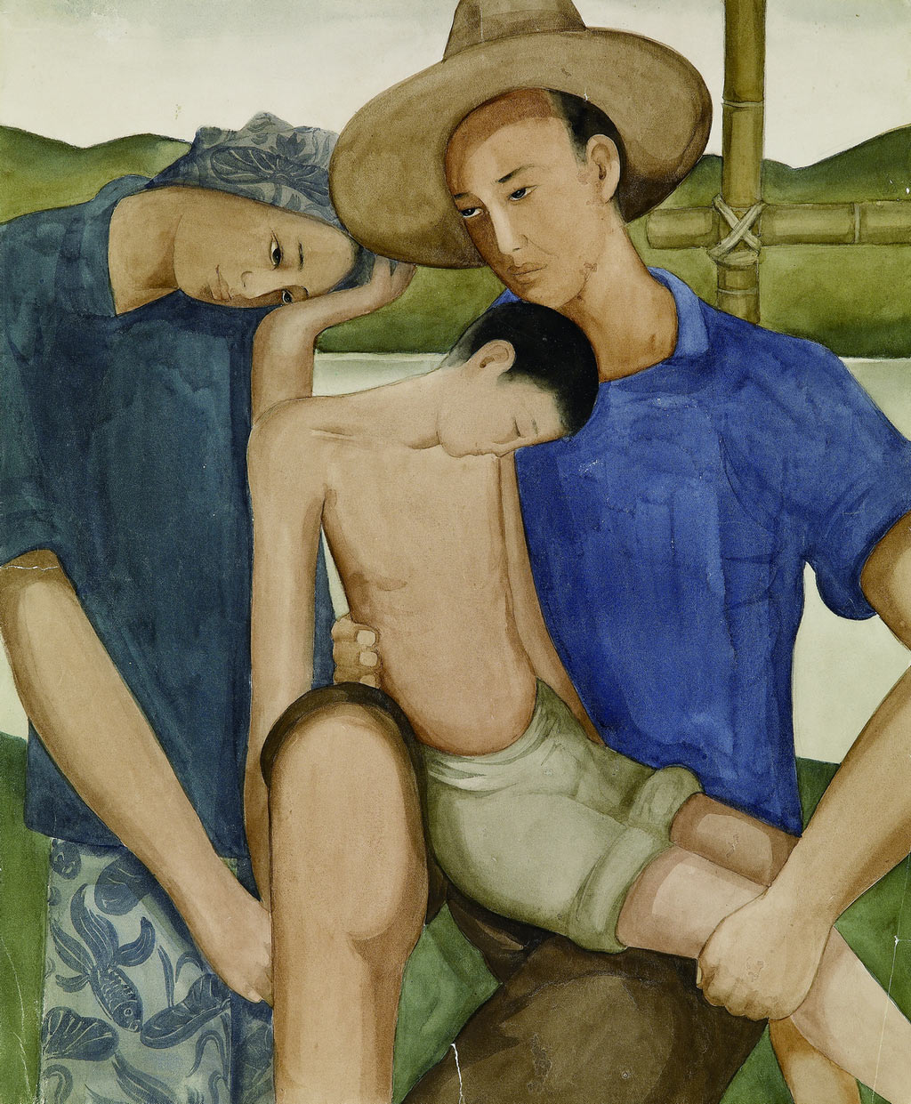

Pang Xunqin (庞薰琹), *Son of the Earth (first draft),* 1934, Watercolor on Paper, 45cm×37cm, Collection Pang Xunqin Museum of Art

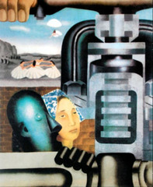

Pang Xunqin (庞薰琹), "Composition", oil, 1935, location unknown, photograph.